**Table of contents**

|  |  |
| --- | --- |
| **job portal system** | Abstract  "Go confidently in the direction of your dreams!"  ANOOD NAZEER |

**Introduction** 3

* Purpose 3
* Scope 3
* Objectives 4

**Functional Requirements** 4

* Primary actors of the system 4
* Use Case Diagram 5
* User Stories 7
* Business Process Diagram 13

**Non-Functional Requirements** 14

**Technical Requirements** 14

**Conclusion** 15

Job Portal System

Software Requirement Specification (SRS)

**Introduction**

Now a day, we know that searching of jobs is so difficult in proficient areas the portal developed for the providing the simple and good job searching. With the help of this portal easily the job seeker can submit their resume and get the lot of opportunity of the job related to their profile. And by this website the companies or employer can also find the good and well profiled resume.

Purpose

The online job Portal System that is to be developed provides the members with jobs information, online applying for jobs and many other facilities. This system provides service to the job applicants to search for working opportunities.

Job Portal will allow job provider to establish one to one relationship with candidates. This Portal will primarily focus on the posting and management of job vacancies. This system is designed such that ultimately all vacancies will be posted online and would offer employers the facilities to post their vacancies online. It helps to review and manage the resulting applications efficiently through the web. Employer can also find the resume according to key skill in very less amount of time.

Scope

The scope of online job portals is vast and continually evolving, driven by technological advancements and changing workforce dynamics. There are essential tools for modern recruitment and job searching.

The scope of a job portal project includes:

* **Job seeker features**: Job seekers can create profiles, upload resumes, and search for jobs.
* **Employer features**: Employers can post job listings, search resumes, and add custom application questions.
* **Admin features**: An admin module can manage the portal, job seeker accounts, and employer accounts.

Objectives

The objective of a job portal system is to provide a centralized platform that connects job seekers with employers efficiently. It simplifies the job search process by allowing users to browse job listings based on criteria like location, skills, and experience while enabling employers to post job openings and find suitable candidates. The system also facilitates resume and profile management, making it easier for users to showcase their qualifications. By streamlining the recruitment process, the job portal saves time and reduces costs for both parties, ensuring an accessible and user-friendly experience.

**Functional Requirements**

Primary actors of the system

In a job portal system, the primary actors are:

**Job Seekers**: Individuals who register on the platform to search and apply for job opportunities. They can create profiles, upload resumes, and receive job recommendations.

**Job Provider**: Companies or organizations that post job vacancies, review applications, and manage recruitment processes. They can search for potential candidates and communicate with job seekers.

**Administrators**: Personnel responsible for maintaining the platform's functionality, managing user accounts, ensuring data security, and overseeing overall system operations.

These actors interact within the system to facilitate efficient job matching and recruitment processes.

Use Case Diagrams

A use case diagram is a visual representation of how users interact with a system, and is a

key tool in the early stages of system design and development.

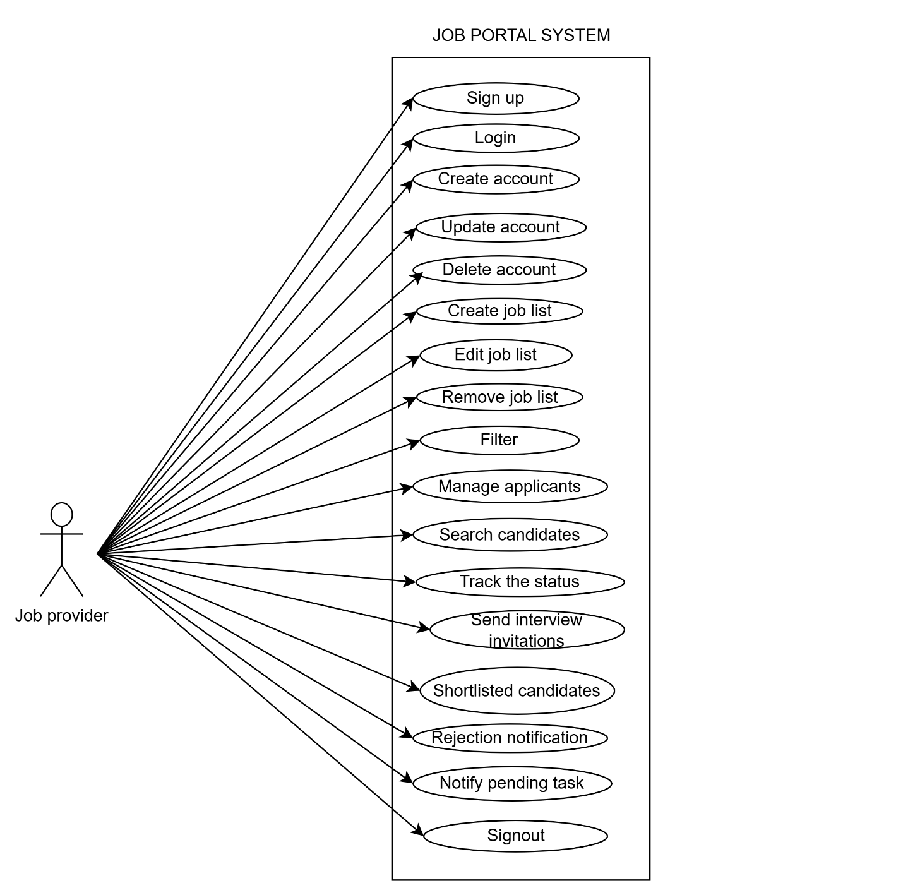

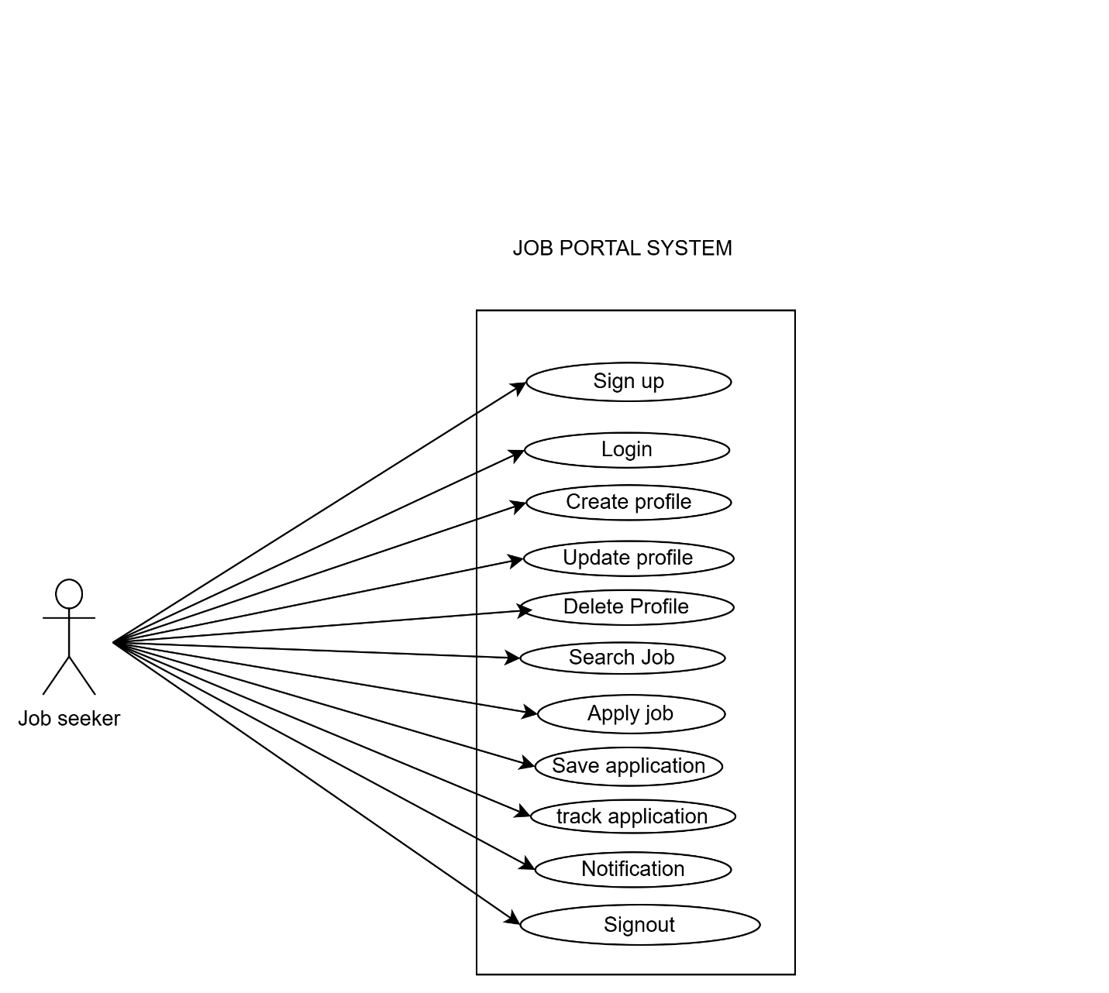

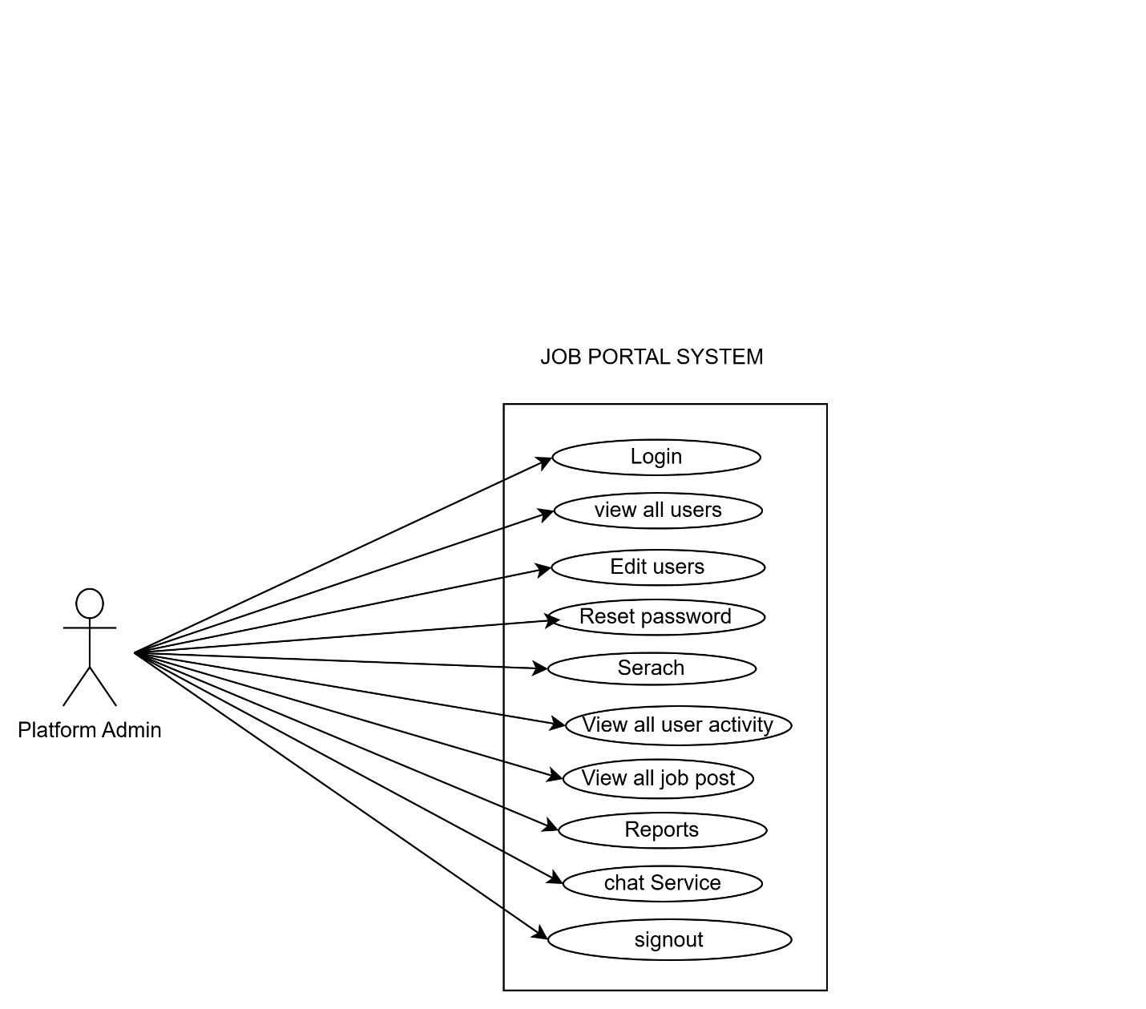

User Stories

A user story is a concise, simple description of a feature or functionality from the perspective of the end user. It outlines what the user wants to achieve and why, focusing on their needs and goals.

|  |  |  |
| --- | --- | --- |
| **AS** | **I NEED TO** | **SO THAT I CAN** |
| Job Provider | Sign up using my email and secure password | Create an account to access the job portal service. |
| Job Provider | Receive a confirmation email after sign up | Know my account was successfully created. |
| Job Provider | Verify my phone number via an OTP | Know my account information is validated. |
| Job Provider | Login using my email and password | Access my account |
| Job Provider | Reset my password If I forget it | Regain access my account. |
| Job Provider | Receive a password reset link via email | Create a new password. |
| Job Provider | Create a company profile with my branding and values | Attract candidates who align with my organization. |
| Job Provider | Update basic company details | My profile reflects the latest information. |
| Job Provider | Delete my company profile | It is no longer visible on the platform if my organization no longer operates. |
| Job Provider | Create a new job listing | Attract suitable candidate. |
| Job Provider | Add job details such as title description, requirements, and location | Applicant understand the role and its expectations. |
| Job Provider | Specify the types of jobs (fulltime, part time, freelance) | Applicants know the nature of the position |
| Job Provider | Include salary or compensation information | Attract the right candidates. |
| Job Provider | Edit an existing job post | Update any outdated information. |
| Job Provider | Remove and deactivate a job post | It is no longer visible when the position is fulfilled. |
| Job Provider | Highlight my job post as featured | It appears prominently to job seekers. |
| Job Provider | Filter through job applications | Easily find suitable candidates. |
| Job Provider | Receive notifications when someone applies | Respond quickly. |
| Job Provider | View analytics for my job post | Measure the respond rate. |
| Job Provider | Manage applicants for my job postings | Find the best fit for the position. |
| Job Provider | View a list of applicants for each job postings | Review their profiles. |
| Job Provider | Filter applications by skills, experience and qualifications | Identify the most relevant candidates. |
| Job Provider | Search for candidates by location | Find individuals who are based near the job sites |
| Job Provider | Search candidates based on their availability such as immediate, within a month | Match their timeline with my hiring needs. |
| Job Provider | Track the status of each applicant such as shortlisted, interviewed, rejected | Manage the hiring process efficiently. |
| Job Provider | Download resume and portfolios | Review them offline. |
| Job Provider | Export application data to my HR system | Integrate it with my internal workflow. |
| Job Provider | I need to see a summary of my active job postings, candidate applications, and recent activity on the dashboard | Get a quick overview of my account. |
| Job Provider | Send messages to applicants directly through the platform | Communicate without sharing personal contact details. |
| Job Provider | Send interview invitations to shortlisted candidates | Schedule meeting easily. |
| Job Provider | Send rejection notification to candidates | They are informed about their application status. |
| Job Provider | Receive reminders about expiring job postings | Renew or update them. |
| Job Provider | Notified of platform updates or new features | Use them effectively. |
| Job Provider | Notified when a candidate updates their applications or profile | I have the latest information |
| Job Provider | Notified pending task such as reviewing applications, scheduling interviews | Ensure timely actions. |
| Job Provider | Alerted when my job post is expiring or inactive | Take necessary actions. |
| Job Provider | Sigh out from any device I am logged | Ensure that my account is secure. |

|  |  |  |
| --- | --- | --- |
| **AS** | **I NEED TO** | **SO THAT I CAN** |
| Job Seeker | Sign up using my email and secure password. | Enter the job portal system. |
| Job Seeker | A confirmation email received after sign up. | Account is created. |
| Job Seeker | Verify phone number through otp. | Account information is being validated. |
| Job Seeker | Login using email and password. | Access my account. |
| Job Seeker | Reset password if it is forgotten. | Regain my account. |
| Job Seeker | Reset new password with link. | Create a new password. |
| Job Seeker | Create a profile | Add essential needs to then profile. |
| Job Seeker | Update by information. | Details can be accurate. |
| Job Seeker | Delete my profile. | Remove all my information and data from the platform. |
| Job Seeker | Search jobs here. | Find many jobs on this platform. |
| Job Seeker | Mention about the convenient location. | Be able to sort out jobs regarding that. |
| Job Seeker | Set salary preferences. | See jobs related to the given information. |
| Job Seeker | Mention about the job type (part time/full time). | Get the preferences according to that. |
| Job Seeker | Mention about the correct areas of jobs. | Easily helps to find different categories of jobs. |
| Job Seeker | Get alert about my profile progress. | It helps to get alerts according to the mentioned filters about job title. |
| Job Seeker | Need to view and apply for the jobs. | Able to find jobs on this platform. |
| Job Seeker | Need to search for jobs according to my desires. | Quickly be able to find jobs according to my interest. |
| Job Seeker | Need to upload my resume/cover letter and other essential things. | That helps to submit my application in the correct way. |
| Job Seeker | Need to apply for jobs by filling out. | Apply for a job without any problem. |
| Job Seeker | Save my application and complete it later. | Which allows my time convenience to complete and submit later? |
| Job Seeker | Want to track the status of my application. | Which can know whether it is shortlisted, rejected or further steps. |
| Job Seeker | Need to receive notifications | Get to know about the details of the status of the jobs. |
| Job Seeker | Need to receive job alerts from new job listings. | Apply as soon as possible. |
| Job Seeker | Need to know whether the employer had received or seemed the application. | Take further steps. |
| Job Seeker | Need to receive a notification whether invited for an interview or not. | I can confirm my availability and preparation. |
| Job Seeker | Able to receive alerts about the expiring dates. | Be able to submit the application as soon as possible. |
| Job Seeker | Be able to upload the certificates if they have been asked. | That the employers can view all the certificates and to know about qualifications. |
| Job Seeker | Sign out of my account. | Ensure my account is secure when I am done. |

|  |  |  |
| --- | --- | --- |
| AS | I NEED TO | SO THAT I CAN |
| Platform Admin | Create a login by entering details | access to job portal system |
| Platform Admin | Verify phone number via OTP | Do Verification process |
| Platform Admin | View a list of all user accounts with filters | Find status of accounts like in active,active,suspended |
| Platform Admin | View detailed profiles of user | Verify their identity ,roles and activity logs |
| Platform Admin | Deactivate user accounts | Users violating policies are restricted from accessing the platform |
| Platform Admin | Permanently delete user accounts | Remove users who don't need the platform or are flagged as fake |
| Platform Admin | Edit user profiles | Correct errors or remove inappropriate content |
| Platform Admin | Reset user passwords upon request | Users who cannot access their accounts can login again |
| Platform Admin | Trigger password reset emails to users | Update their passwords securely |
| Platform Admin | Search for users by specific attributes like email,username,status | Quickly locate the account |
| Platform Admin | View the activity logos of a specific user like login history, job applications | Monitor suspicious or in appropriate behaviour |
| Platform Admin | View all job post on the platform with filters | I can monitor the platform activity |
| Platform Admin | Review and approve job posts submitted by recruiters | Only real and valuable opportunities are posted on the platform. |
| Platform Admin | Reject job posts | Reject job post violated platform policies |
| Platform Admin | Delete job posts | Maintains platform integrity and quality |
| Platform Admin | Provide feedback when rejecting a job post | Recruiters can understand correct issues |
| Platform Admin | Review job posts reported by users | Investigate and take appropriate action |
| Platform Admin | Generate reports on job posts by category, industry or location | Share insights with the business team |
| Platform Admin | Generate reports on job posts like most popular industries, locations | Identify trends and improve the platform |
| Platform Admin | Sign out | Secure my account from others |

Business Process Diagram

BPMN (Business Process Model and Notation) is a standardized graphical representation used to model business processes. It provides a clear, visual method for documenting and analyzing workflows, making them easier to understand and communicate. BPMN uses symbols like events, activities, gateways, and flows to depict the sequence and interactions of tasks in a process. It is widely used to bridge the gap between business analysts and technical teams, ensuring better process management and automation.

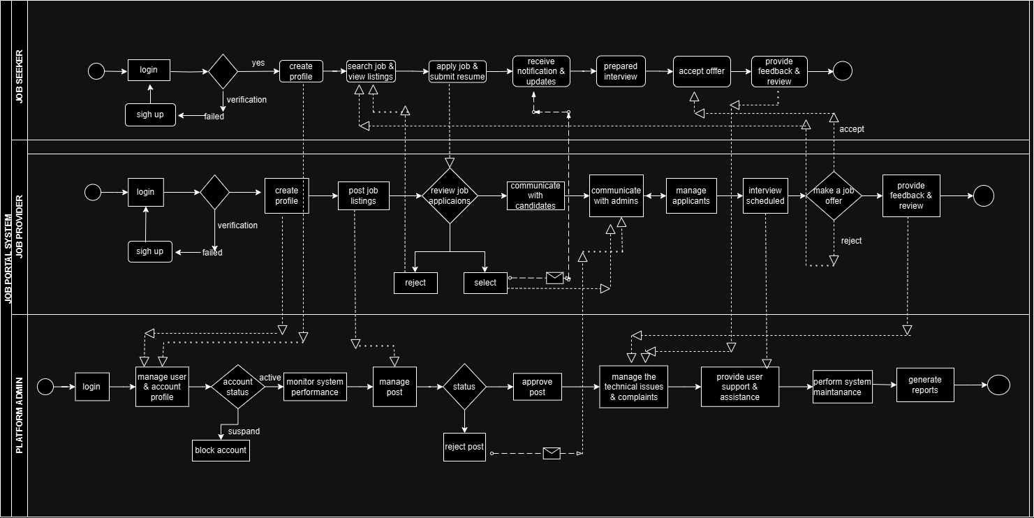

**Non-Functional Requirements**

Non-functional requirements for a job portal system ensure its reliability, scalability, and user experience. The system must handle high user traffic efficiently, provide search results within seconds, and maintain 99.9% uptime with robust backup and recovery mechanisms. It should adhere to data protection laws like GDPR, encrypt sensitive data, and integrate seamlessly with third-party services. Accessibility, multilingual support, and intuitive navigation are essential for usability, while modular design ensures maintainability. Security measures, including multi-factor authentication and fraud prevention, safeguard user data, and audit logs track activities for compliance and monitoring purposes.

**Technical Requirements**

Processor: Intel(R) Core (TM) i7-8665U CPU @ 1.90GHz 2.10 GHz

Installed RAM: 8.00 GB

System type: 64-bit operating system, x64-based processor

Operating System: Windows 11 Pro

Storage: 237 GB

Web Development: HTML, CSS, JAVA script, Angular, Bootstrap

Database: MySQL

Frame work: ASP.Net core, Visual Studio

**Conclusion**

A conclusion for an online job portal system might read:

The online job portal system serves as an efficient and user-friendly platform bridging the gap between job seekers and employers. It streamlines the recruitment process, offering features such as advanced search options, profile management, and real-time job postings. By leveraging modern technology, it enhances accessibility, reduces hiring time, and ensures a tailored experience for users. This system not only simplifies the job search process but also fosters transparency and connectivity in the labor market. With continuous updates and enhancements, it holds the potential to significantly contribute to the employment ecosystem and cater to evolving industry needs.